NodeConfigurator — Complete Project Report
MAUI Blazor Hybrid modular UI system (Phase 1 → Phase 3)

1. Executive Summary
NodeConfigurator is a .NET MAUI Blazor Hybrid desktop host designed as an extensible shell that loads modular UI extensions. The project evolved through three phases: (1) a modular demo with three extensions and cross-extension rules, (2) a UX refactor to per-node configuration while preserving Phase 1 behavior, and (3) a runtime plugin architecture enabling independent teams to ship extensions without rebuilding the host, with dependency isolation via per-plugin AssemblyLoadContext.

2. Tech Stack
- .NET MAUI Blazor Hybrid (.NET 10)
- Razor components (extension UI)
- In-memory publish/subscribe event bus (in-process)
- System.Text.Json persistence (JSON save/restore)
- Runtime plugin loading from disk (C:\plugins\*)
- AssemblyLoadContext + AssemblyDependencyResolver (per-plugin dependency isolation)

3. Phase 1 — Initial Build (Demo Done)
Built a desktop host shell that loads modular UI extensions, with three working extensions and full validation + persistence.
- Extensible shell — host loads multiple independent UI extensions
- Central Node extension — select one computer as the central node
- Identity extension — configure identity provider (None / GitHub / EntraID / PingID) for the central node
- Mode extension — toggle Connected / Disconnected
- Single central-node rule — only one node can be central at a time
- Cross-extension validation — if Mode = Connected, Identity must = EntraID, else show a validation error
- Persistence — configuration saved to JSON
- State restore — full state reloaded on startup
- Node navigation — browse nodes and view aggregated details
- UI — extensions presented as separate sidebar tabs
Figure 1 — Phase 1 architecture (sidebar tabs).
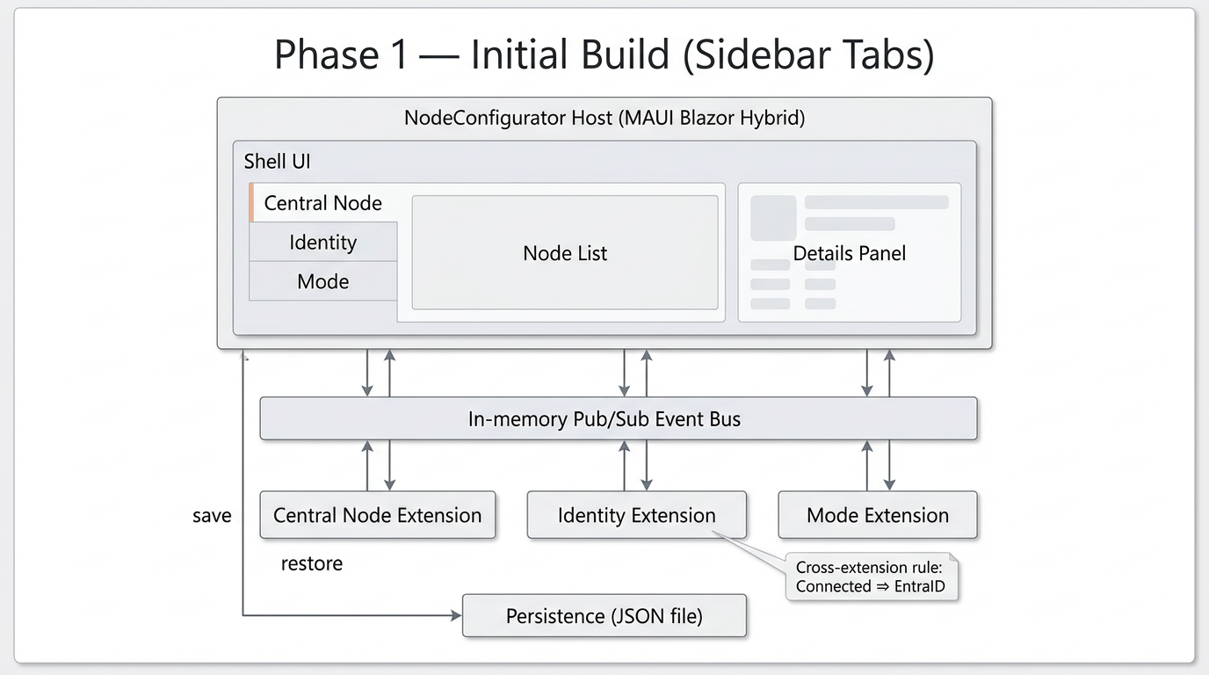

4. Phase 2 — UI Refactor (Demo Done)
Reworked the UI for clearer per-node configuration while keeping all Phase 1 behaviors intact.
- Per-node configuration — central node and identity configuration moved onto each node’s page
- Single central-node rule enforced in-line — selecting a central node auto-updates the others
- Conflict surfaced on the node — Connected-requires-EntraID conflict shown directly on affected node
- Action-based saving — saves happen on Save / navigation / close (not continuous writes)
- All Phase 1 validation & persistence preserved
Figure 2 — Phase 2 architecture (per-node configuration).

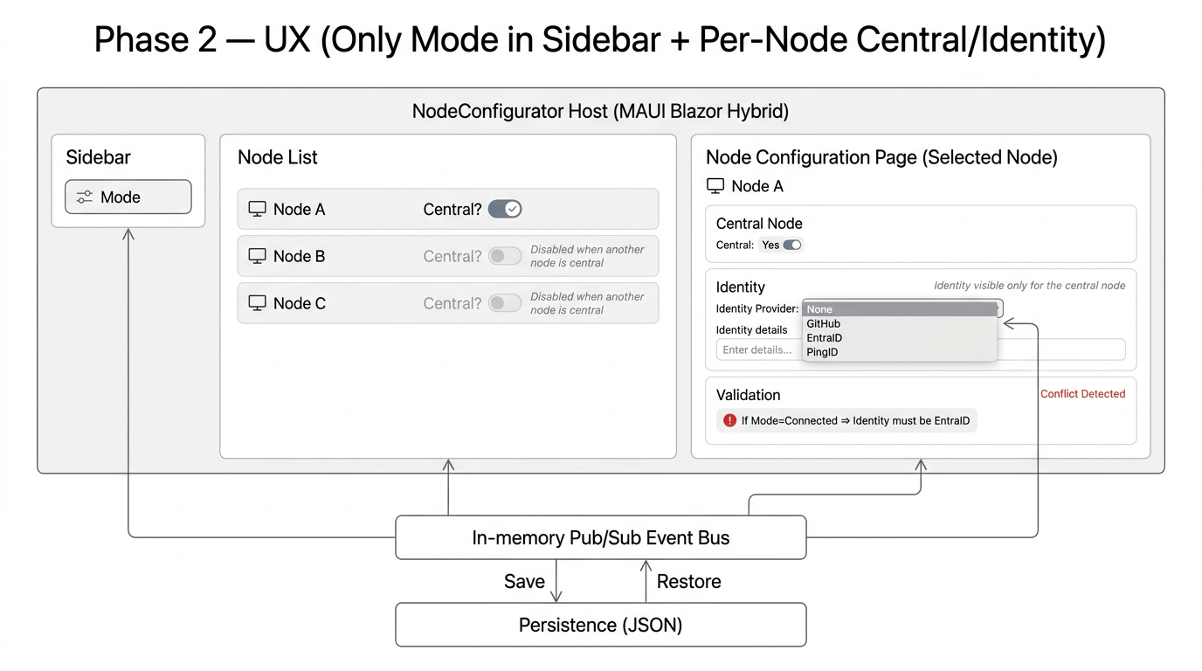

5. Phase 3 — Runtime Plugin Isolation (Achieved)
Decoupled the system so each extension is independently shippable and loadable at runtime, with dependency isolation per plugin.
- Independent teams — each extension built in its own repo with its own dependencies and version
- Runtime loading — host discovers and loads extensions at runtime (no compile-time references)
- Version flexibility — run different extension sets/versions without recompiling the host
- Dependency isolation — conflicting dependency versions can coexist via per-plugin AssemblyLoadContext
Figure 3 — Phase 3 architecture (runtime plugin isolation).
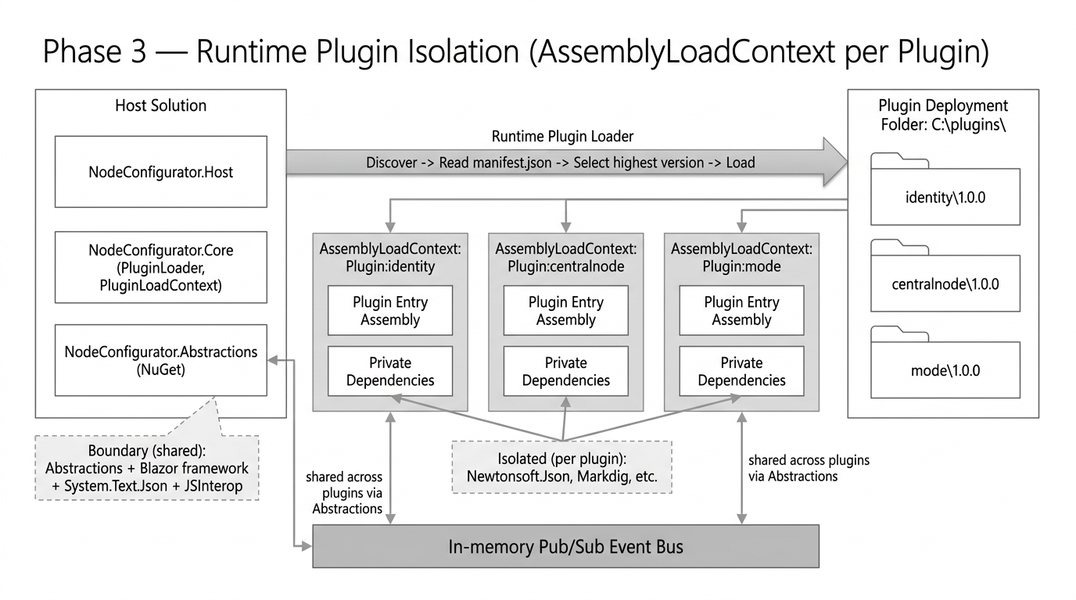

6. Runtime Plugin Architecture (Phase 3)

6.1 Physical layout
Host solution (compiled once):
• NodeConfigurator.Host (MAUI Blazor Hybrid UI shell)
• NodeConfigurator.Core (PluginLoader, PluginLoadContext, registry)
• NodeConfigurator.Abstractions (contract NuGet package)
Plugins (independent repos) are deployed outside the host install folder:
C:\plugins\<pluginId>\<version>\

6.2 Plugin lifecycle
High-level flow: discovery → manifest parsing → version selection → ALC creation → dependency resolution → assembly load → IExtension instantiation → initialization/hydration → rendering.
Key behaviors:
- Host can continue even if a plugin fails (fail-safe / ContinueOnError).
- Highest-version folder for a given plugin id wins.
- Plugins are rendered as first-class Razor components using Blazor DynamicComponent.

6.3 AssemblyLoadContext isolation and the boundary
Each plugin loads into its own collectible AssemblyLoadContext (ALC) named Plugin:<id>. Private dependencies resolve from the plugin folder via AssemblyDependencyResolver using the plugin’s .deps.json. A small shared boundary is intentionally loaded from the host (default ALC) to preserve single type identity across host↔plugin interactions.
Boundary (shared) examples:
- NodeConfigurator.Abstractions (IExtension, IExtensionContext, shared DTOs)
- System.Text.Json (JsonElement used on the contract surface)
- Microsoft.AspNetCore.Components* (Blazor component model required for rendering)
- Microsoft.JSInterop and DI/logging abstractions used across the boundary
Isolated (per-plugin) examples:
- Newtonsoft.Json (different versions per plugin)
- Markdig (different versions per plugin)
- Other helper/data libraries not present on the boundary

7. Event Bus (Publish/Subscribe)
NodeConfigurator uses an in-process publish/subscribe event bus to enable communication between the host and extensions (and extension-to-extension) without direct compile-time references.

7.1 Why it exists
- Decouples host and extensions: messages are exchanged by topic + JSON payload.
- Enables cross-extension validation and coordination without referencing other extension assemblies.
- Supports host broadcasts (e.g., node selection changes) and extension updates (e.g., identity/mode changes).

7.2 Message shape and boundary reasoning
Messages are represented by a contract type from Abstractions (e.g., BusMessage). The payload is a System.Text.Json JsonElement. JsonElement is on the boundary by design so payload values can cross ALC boundaries safely with one type identity; this is why System.Text.Json must be shared.

7.3 Flow diagram
Figure 4 — Event bus publish/subscribe flow.
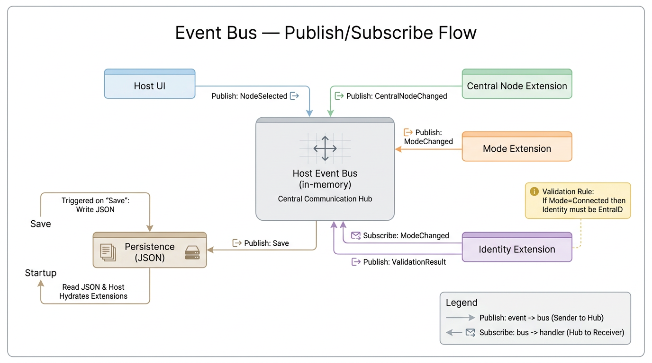

7.4 Practical guidance
- Handlers should be fast. If long work is needed, queue it or run it asynchronously.
- If a subscriber updates Blazor UI, marshal back to the UI dispatcher (e.g., InvokeAsync(StateHasChanged) from a component).
- Prefer namespaced topics (e.g., ext.identity.updated) and document payload shapes.
- Avoid throwing exceptions from handlers; catch and log to prevent disruption.

8. Configuration, Persistence, and Restore
The host owns persistence and writes configuration to JSON. Extensions participate by hydrating from saved JSON and serializing their own config slices back to JSON.

8.1 Save triggers
- Phase 2+ uses action-based save: Save button / navigation / app close.
- On save, the host composes a snapshot (nodes + per-extension config slices) and writes it atomically.

8.2 Restore (startup)
- Host loads plugins first, then loads saved state.
- Host calls InitializeAsync(context) then HydrateAsync(savedConfig) per extension.
- Failures are isolated; a broken extension should not prevent the host from starting.

9. Isolation Proof Tests (Newtonsoft.Json + Markdig)
This project includes a repeatable isolation proof where two plugins load two different versions of Newtonsoft.Json and Markdig simultaneously, each from its own plugin folder and ALC.
Test matrix:
• Identity: Newtonsoft.Json 12.0.3 ; Markdig 0.31.0
• CentralNode: Newtonsoft.Json 13.0.3 ; Markdig 0.38.0

9.1 Pass criteria
- Both plugin folders contain: Newtonsoft.Json.dll, Markdig.dll, and the plugin entry .deps.json.
- Runtime logs show different versions and assembly locations under each plugin folder.
- AssemblyLoadContext names differ per plugin (Plugin:identity vs Plugin:centralnode).

MARKDIG (V 0.38.0.0) IN CENTRAL NODE EXTENSION
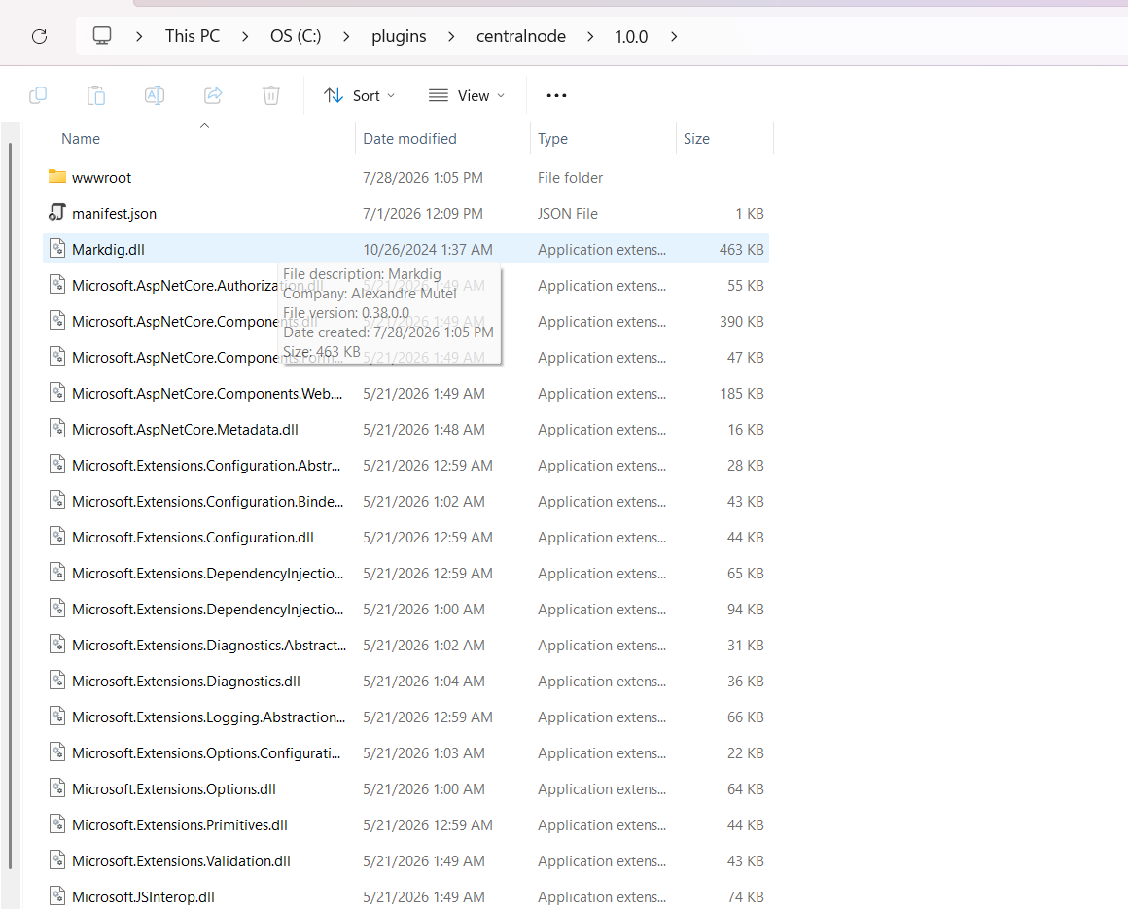
MARKDIG (V 0.31.0.0) IN IDENTITY EXTENSION

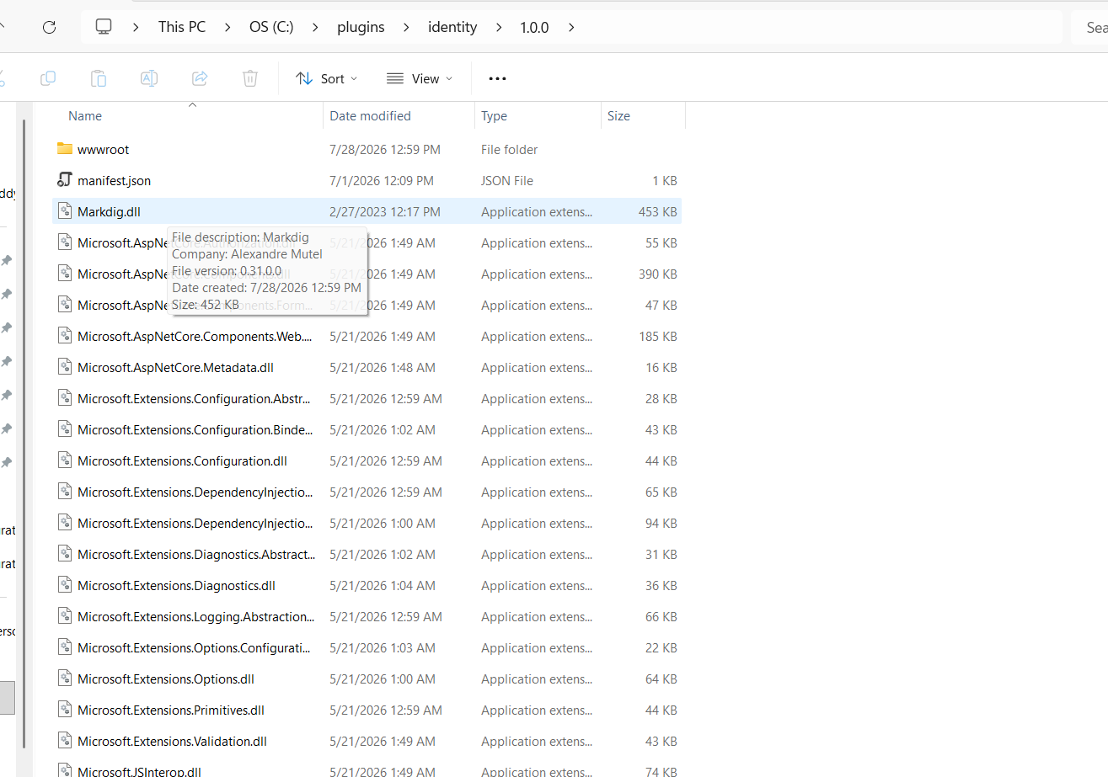

NEWTONSOFT.JSON (V 13.0.3.27908) IN CENTRAL NODE EXTENSION
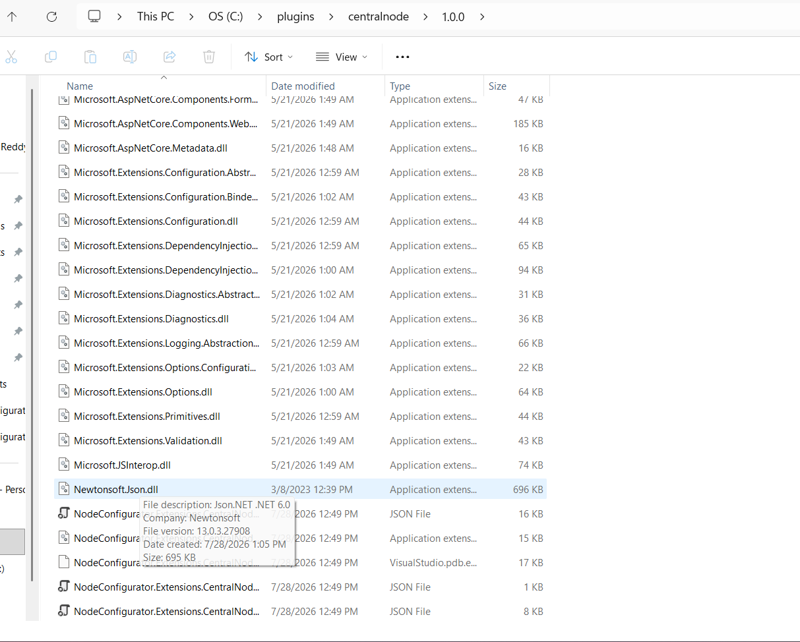

NEWTONSOFT.JSON (V 12.0.3.23909) IN IDENTITY EXTENSION

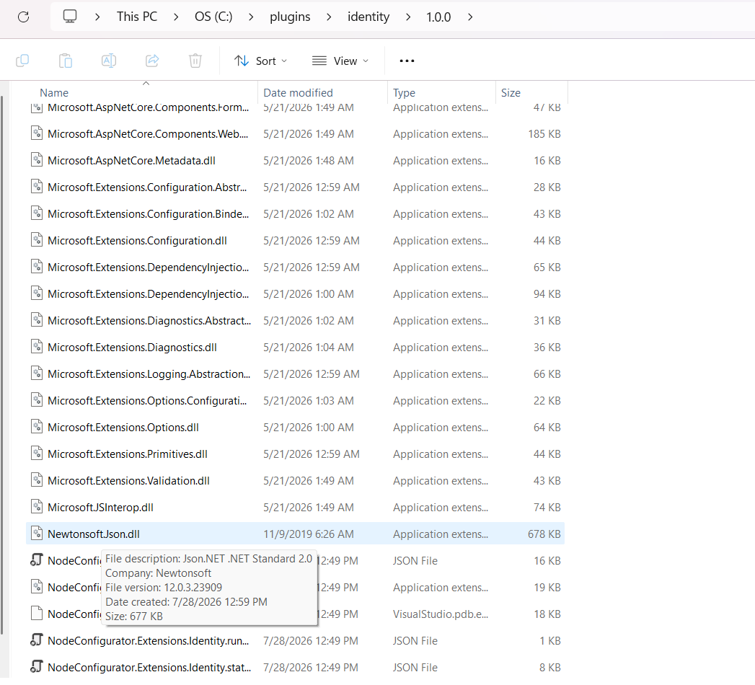

PROCESS EXPLORER
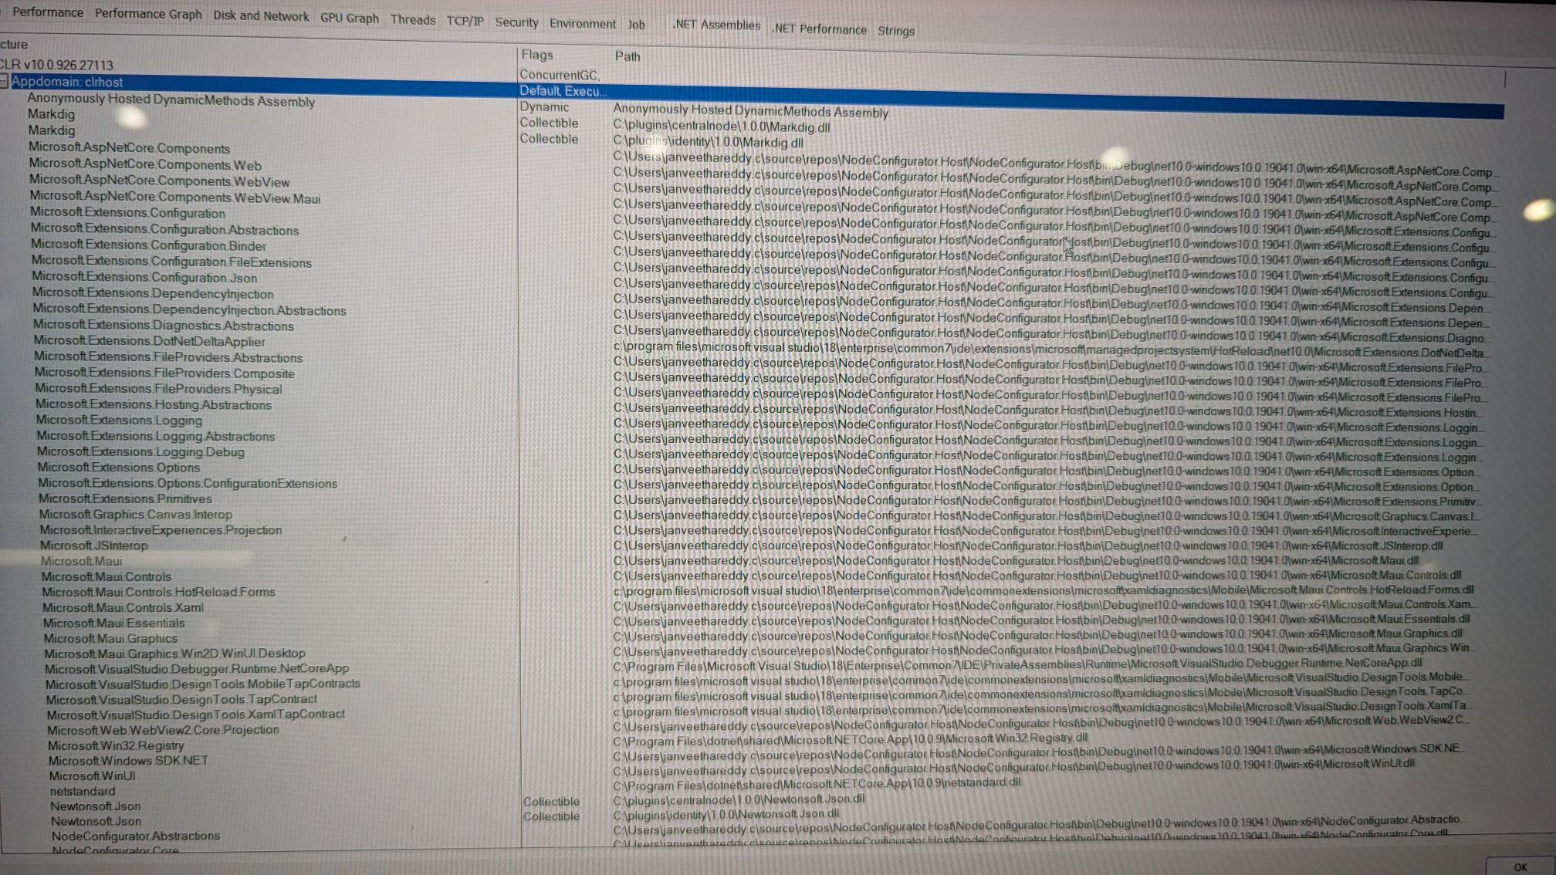

9.2 Publish commands (PowerShell)
Stop the host before publishing (to avoid file locks), then run:
Remove-Item "C:\plugins\identity\1.0.0" -Recurse -Force -ErrorAction SilentlyContinue
dotnet publish "C:\repos\Extension.Identity\NodeConfigurator.Extensions.Identity" -c Release -o "C:\plugins\identity\1.0.0"
Remove-Item "C:\plugins\centralnode\1.0.0" -Recurse -Force -ErrorAction SilentlyContinue
dotnet publish "C:\repos\Extension.CentralNode\NodeConfigurator.Extensions.CentralNode" -c Release -o "C:\plugins\centralnode\1.0.0"

9.3 Troubleshooting
- If publish fails with “file is being used”: close the host app (Shift+F5) and retry.
- Publish the plugin project/folder (not the solution) to avoid output warnings.
- If DLLs do not appear: confirm PackageReference versions, disable trimming for the test, and ensure code references the libraries so publish includes them.

